Lab 3 – Interpretation of sedimentary rocks – ELTT Fall 2021

1. The photograph below shows interbedded coals and sandstones.

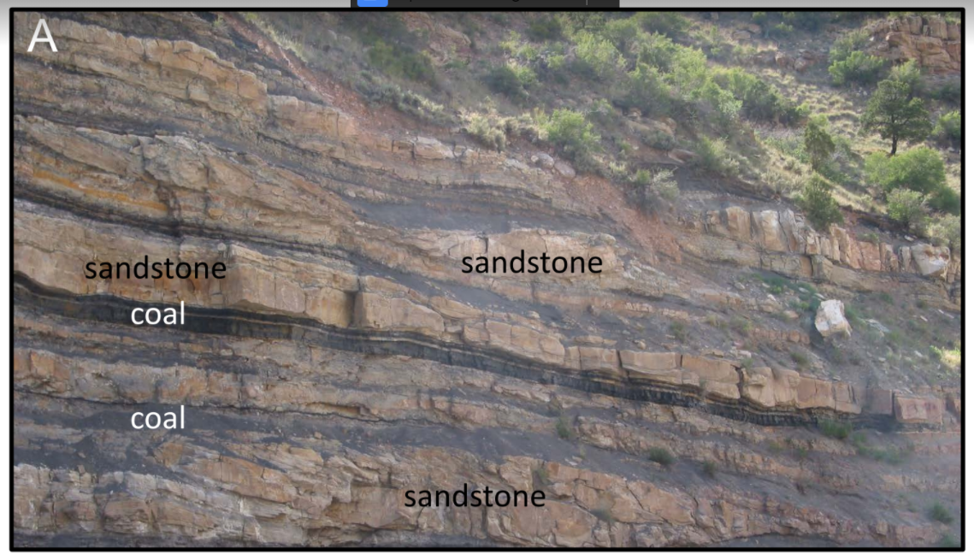

1. What is the most likely depositional environment for the coals?

* The most depositional environment for coal would be Transitional, like marshes and swamps.

1. What can you say about oxygen amount in this depositional environment? Is there any visual element in coal beds that leads you to your answer?

* This environment has a low amount of oxygen. Coal beds are formed in low oxygen level environments as shown by how it can’t hold its form.

1. Which one is a wave ripple? Why? Indicate the direction of the flow on B.

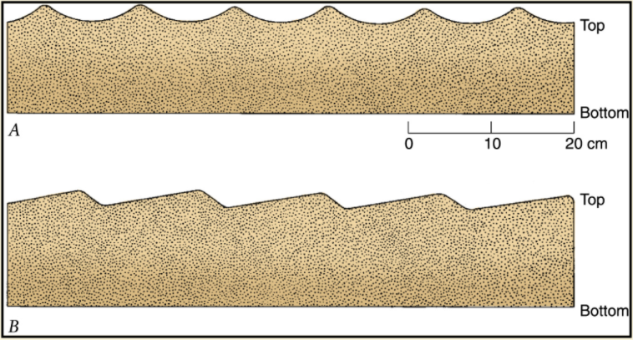

* The flow of A is the wave ripple. The waves in the picture are symmetrical.

1. Observe the following photographs:

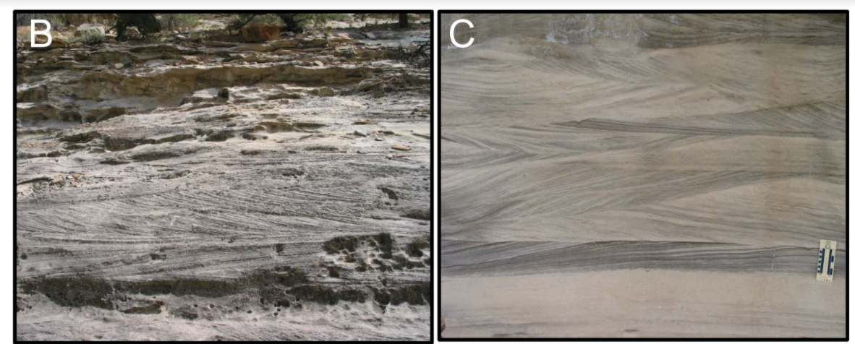

1. What sedimentary structures do you see in photographs B and C?

* Image C is showing a cross-bedding structure. Image B is showing a ripple effect.

1. What can you say about the current direction on photograph C? Is it uni-directional or bi-directional? What is the most likely depositional environment?

* The direction of image C are bi-directional. A likely environment are sand dunes and avalanche faces.

1. Photographs D and E show bedding surfaces with symmetrical ripples and dinosaur trackways, respectively. What do these features indicate about depositional environment for the beds illustrated?

* The environment for the bedding example D may be an ocean or a windy sand dunes. Example E

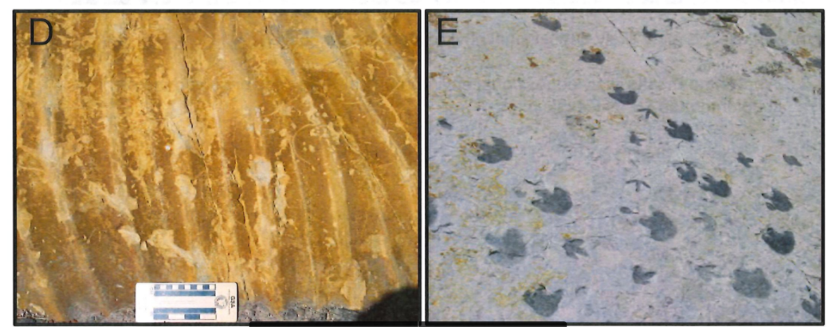

1. Based on features visible in the photographs, what can you infer about:

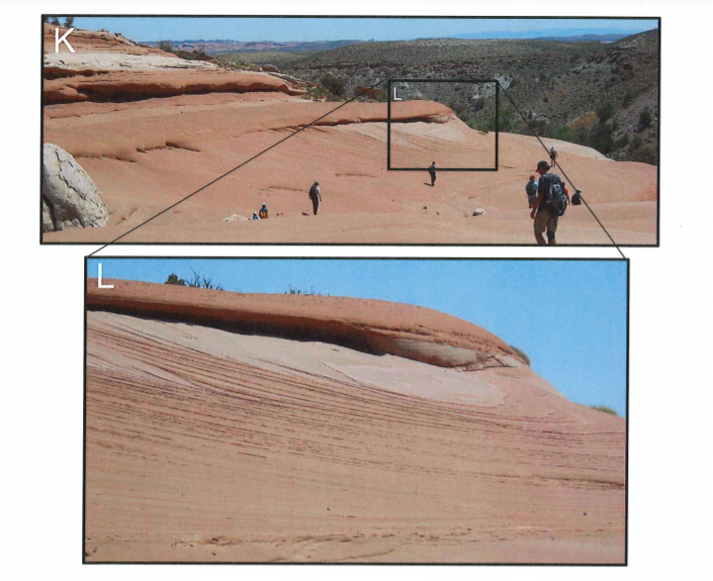

1. environment of deposition of these sediments?

* Images K and L show signs of a parallel lamination environment so like sand dunes.

1. paleoclimate in this region?

* The paleoclimate is hot and dry.

1. Match the sedimentary structure with the environment most likely to form it:

__e_ Mudcracks a. Wave dominated shoreline

_d__ Flute casts b. River

__a_ Symmetric ripples c. Glaciers

__b_ Large cross-bedding in well sorted sandstones d. Deserts

__c_ Striations on rock surface e. Lake

1. If a stream flows at 3 cm/sec, what is the largest sediment size that can be transported? What happens if the velocity drops to 0.5 cm/sec?

* The largest sediment size would be sand. If the velocity drops to 0.5 cm/sec, it would being to be deposited.

1. What are the three broad categories of depositional environments? Give one example of each.

* Continental (swamp, alluvial fan, glacial environment), Transitional (barrier island, reef, delta), and Marine (Deep marine, shallow marine, rise)

1. What are the main characteristics of a sedimentary rock formed in a glacial environment?
2. What is the sedimentary structure showed in the photograph below? What can you say about changes in depositional energy?

